Experiment 3.1.1
Algorithm: Find the Largest of Three Numbers
Step 1: Start
Step 2: Read three integers a, b, and c
Step 3: If a > b then
→ If a > c, print a
→ Else, print c
Step 4: Else (a ≤ b)
→ If b > c, print b
→ Else, print c
Step 5: Stop

Flowchart:
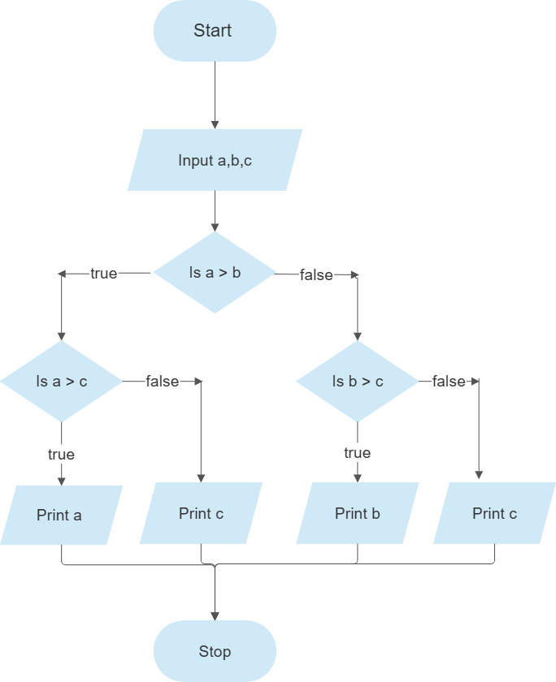

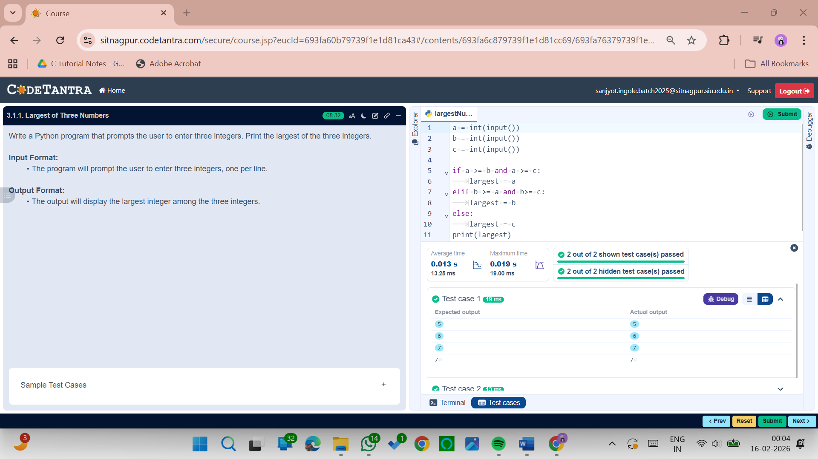
Experiment 3.1.2
Algorithm: Convert Celsius to Fahrenheit
Step 1: Start
Step 2: Read temperature in Celsius (celsius)
Step 3: Calculate Fahrenheit using the formula
$$fahrenheit= \left(celsius ×\frac{9}{5}\right)+32$$
Step 4: Display the Fahrenheit value
Step 5: Stop

Flowchart:
